**INDUSTRY WATCH**



By

**ADEEL SHAHID KHAN** **(2020-ARID-3593)**

**ABDULLAH MUSTAFA** **(2020-ARID-3588)**

**USAMA FAYYAZ**  **(2020-ARID-4232)**

**MUHAMMAD ANEES**  **(2020-ARID-3694)**

**Bachelor of Science in Computer Science**

**(BSCS)**

**Barani Institute of Information Technology**

**PMAS Arid Agriculture University Rawalpindi**

**Spring 2024**

**INDUSTRY WATCH**



A report submitted in partial fulfillment of the

requirements for the degree of

**Bachelor of Science in Computer Science**

Submitted By

**ADEEL SHAHID KHAN** **(2020-ARID-3593)**

**ABDULLAH MUSTAFA** **(2020-ARID-3588)**

**USAMA FAYYAZ**  **(2020-ARID-4232)**

**MUHAMMAD ANEES**  **(2020-ARID-3694)**

Supervised By

**DR. HASSAN NAZEER CHAUDHRY**

**Barani Institute of Information Technology**

**PMAS Arid Agriculture University Rawalpindi**

**Spring 2024**

# CERTIFICATE

It is certified that the contents and form of thesis entitled **Industry Watch** submitted by **Adeel Shahid Khan, Abdullah Mustafa, Muhammad Anees and Usama Fayyaz** have been found satisfactory for the requirement of the degree.

**SUPERVISORY COMMITTEE**

**PROJECT SUPERVISOR: _____________________**

**Dr. Hassan Nazeer Chaudhry**

**REPORT COORDINATOR: _____________________**

**Mr. Adeel Sohail**

**WRITEUP COMMITTEE HEAD: _____________________**

**Dr. Mohsin Raza**

# ACKNOWLEDGEMENT

We, as a group, extend our heartfelt gratitude to all those who have contributed to our academic journey and the completion of this dissertation. Their unwavering support, guidance, and encouragement have been invaluable.

We express our sincere appreciation to our supervisor Dr. Hassan Nazeer for his exceptional guidance, expertise, mentorship, expert advice, and continuous support throughout the project. Your valuable insights, mentorship, and encouragement have been instrumental in shaping the project's direction and ensuring its success.

A special word of thanks to our advisor, Mr. Adeel Sohail. His commitment to our academic growth has significantly shaped this research.

We would like to acknowledge the members of the examination committee for their valuable feedback and critical insights. Their rigorous evaluation has enriched the quality of our work.

Our peers and colleagues deserve recognition for their constructive discussions, resource sharing, and encouragement throughout this journey. Their camaraderie has made this experience memorable.

Lastly, we are indebted to our families and friends for their unwavering support, patience, and understanding. Their belief in our abilities has been our driving force.

This dissertation would not have been possible without the collective efforts of all group members. Thank you all.

# ABSTRACT

Industry Watch presents a comprehensive monitoring system designed to enhance workplace efficiency and product quality through two distinct modules: Employee Monitoring and Quality Monitoring. The Employee Monitoring module enforces adherence to workplace regulations by tracking activities such as smoking, mobile usage, and sitting behavior. By ensuring compliance with these rules, the system aims to promote a healthier and more productive work environment.

The Quality Monitoring module is dedicated to overseeing the production process of three types of products: water bottles, metal disks, and fabric. This module employs advanced monitoring techniques to ensure that each product meets predefined quality standards, thereby reducing defects and improving overall product reliability. (Thompson, Rebecca, & al, 2023)

Through the integration of these modules, the project seeks to establish a dual-faceted approach to workplace and product quality management. The implementation of this system is anticipated to result in increased productivity, enhanced employee well-being, and superior product quality, ultimately contributing to the overall efficiency and success of the organization. Future work can focus on improving industry watch on the multiple products and multiple rules of employee monitoring.

**TABLE OF CONTENTS**

**Contents**   **Page No.**

**CERTIFICATE** ii

**ACKNOWLEDGEMENT** iii

**ABSTRACT** iv

**LIST** **OF** **FIGURES** vii

**CHAPTER 1 -** **INTRODUCTION** 1

1.1 Introductory Background 1

1.2 Problem Statement 2

1.3 Proposed Solution 3

1.4 Project Scope 4

1.5 Objectives 4

**CHAPTER 2 -** **BACKGROUND** 6

2.1 Related Projects and Research Article 7

2.2 Screenshots of Related Projects 9

2.2.1 Background 9

2.2.2 Key Features 9

2.2.3 Benefits 10

2.2.4 Screenshots 11

**CHAPTER 3 -** **CONCEPTUAL** **DESIGN** 19

3.1 Requirement Elicitation 19

3.2 Requirement Specification 19

3.2.1 Functional Requirements 19

3.2.2 Non Functional Requirements 21

3.2.3 Domain Requirements 21

3.3 Logical Design 21

3.3.1 Conceptual Diagram 21

3.4 Database Design 23

3.4.1 Entity Relationship Diagram 23

**CHAPTER 4 -** **IMPLEMENTATION** 24

4.1 Tools and Technologies 24

4.2 Pseudo Code 24

4.3 Graphical User Interface 31

4.4 Algorithms 52

**CHAPTER 5 -** **CONCLUSION** 53

5.1 Concluding Remarks 53

5.2 Future Direction 53

5.3 Limitations 53

**REFERENCES** 54

**ANNEXURE** 55

# LIST OF FIGURES

**Figure**  **Page No.**

Figure 2.1 - Add Organization……………………………………………………….12

Figure 2.2 - Add Productivity Rule…………………………………………………..13

Figure 2.3 - Add Section……………………………………………………………..14

Figure 2.4 - Assign Productivity Rule………………………………………………..15

Figure 2.5 - Productivity Inspection………………………………………………….16

Figure 2.6 - Violation Detail…………………………………………………………17

Figure 2.7 - Add Product……………………………………………………………..18

Figure 2.8 - Product Inspection………………………………………………………19

Figure 3.1 - Conceptual Diagram…………………………………………………….23

Figure 3.2 - ERD……………………………………………………………………..24

Figure 4.1 - Login Screen…………………………………………………………….32

Figure 4.2 - Admin Dashboard……………………………………………………….33

Figure 4.3 - Employee Record……………………………………………………….34

Figure 4.4 - Employee Productivity Detail…………………………………………..35

Figure 4.5 - Attendance Screen………………………………………………………36

Figure 4.6 - Violations Screen………………………………………………………..37

Figure 4.7 - Employee Summary…………………………………………………….38

Figure 4.8 - Production Dashboard…………………………………………………..39

Figure 4.9 - Add Product………………………………………………………….….40

Figure 4.10 - Add Material……………………………………………………….…..41

Figure 4.11 - Products Screen…………………………………………………….….42

Figure 4.12 - Link Product Screen…………………………………………………...43

Figure 4.13 - Batches Screen………………………………………………………...44

Figure 4.14 - Batch Details Screen……………………………………………….….45

Figure 4.15 - Supervisor Dashboard………………………………………………....46

Figure 4.16 - Employee Monitoring Screen ………………………………………...47

Figure 4.17 - Employee Monitoring Summary ……………………………………...48

Figure 4.18 - Defect Monitoring Screen.………………………………………….…49

Figure 4.19 - Defect Monitoring Summary………………………………………….50

Figure 4.20 - Mark Attendance Screen………………………………………………51

Figure 4.21 - Employee Home Screen………………………………………….……52

**Chapter 1**

# INTRODUCTION

The Industry Watch is an application designed for Android, iOS, React Native, and Flutter, with Python Flask as the backend. By using this app, industries can enhance employee productivity by applying rules to various sections and assigning fines to employees. Additionally, this application ensures the quality of products by identifying defective items in the finished product and preventing them from reaching the market. This helps in satisfying customer needs by delivering quality products.

## 1.1 Introductory Background

Every Industry aims for its employees to be more productive, as productive employees can complete high-quality work within specific time frames. This efficiency allows them to meet deadlines, achieve their goals, and significantly contribute to the company’s success. Additionally, industries strive to ensure customer satisfaction through the quality of their finished products. Currently, ensuring product quality involves manual checking by employees, which is time-consuming, prone to human error, and makes it difficult to calculate the overall yield of a specific batch accurately.

Manual employee monitoring poses several challenges. Firstly, it is inefficient and labor-intensive. Supervisors must constantly observe employee activities, which diverts their attention from more strategic tasks. Secondly, manual monitoring is inconsistent, as human supervisors can overlook certain behaviors or enforce rules inconsistently, leading to discrepancies in productivity and adherence to company policies.

To address these issues, we propose an innovative solution: a cross-platform mobile application that serves as a digital replacement for traditional manual monitoring. This application, compatible with Android, iOS, React Native, and Flutter, uses Python Flask as its backend. It enhances productivity by applying rules to specific sections and assigning fines to employees who do not comply. The system employs overhead cameras to monitor employees' activities according to predefined rules, ensuring consistent and accurate monitoring. Furthermore, employees can check their violations whenever they want through the app, allowing them to identify and correct their mistakes, thereby improving their productivity. (Johnson, Emily, & al, 2023)

In terms of product quality assurance, this application automates the detection of defects in finished products using an overhead camera on the production line, preventing defective items from reaching the market (Brown, Michael, & Lee, 2021). The automation not only reduces the time and labor required for quality checks but also minimizes human error. Additionally, the project calculates the yield of each batch by maintaining a count of defective products and averaging the results. By comparing the defect percentage with a predefined rejection tolerance percentage, which is input during batch creation, the system determines whether a batch is accepted or rejected.

The significance and importance of this project lie in its ability to streamline both employee productivity monitoring and product quality assurance. By leveraging technology, the application ensures a more efficient, accurate, and reliable process, ultimately contributing to the overall success and reputation of the industry. This solution not only improves operational efficiency but also enhances customer satisfaction by consistently delivering high-quality products. This System is also designed to be user-friendly and to simplify the process for everyone involved in the Industry.

## 1.2 Problem Statement

In the quest for higher productivity and quality assurance, Industries face significant challenges with manual monitoring of employees and product quality. Manual employee monitoring is inefficient and labor-intensive, requiring constant supervision that diverts attention from strategic tasks. This method is also prone to inconsistencies and human error, leading to discrepancies in productivity and rule enforcement. Additionally, ensuring product quality through manual checks is time-consuming and error-prone, making it difficult to accurately calculate the overall yield of a specific batch. These issues hinder the ability to meet deadlines, achieve goals, and deliver high-quality products that satisfy customer expectations.

To address these challenges, there is a need for a comprehensive, automated solution that can monitor employee activities and product quality in a consistent, accurate, and efficient manner. The solution should enable employees to check their violations and improve their performance, while also automating defect detection in finished products to ensure only high-quality items reach the market. This approach will streamline operations, reduce human error, and enhance both productivity and product quality, ultimately contributing to the overall success and reputation of the industry. (Williams, Lisa, & Green, 2023)

## 1.3 Proposed Solution

To overcome the challenges of manual employee and product quality monitoring, we propose Industry Watch. This app will use overhead cameras to monitor employees in real-time, enforcing rules on smoking, mobile usage, and sitting. (Taylor, Robert, & al, 2022) It will automatically apply rules and fines, and allow employees to check their violations, helping them improve their productivity.

For quality assurance, Industry Watch will detect defects in finished products like water bottles, metal disks, and fabric, preventing faulty items from reaching the market. It will track defective products in each batch, calculate the yield, and compare defect percentages with rejection tolerance to decide if a batch is accepted or rejected.

Implementing Industry Watch will automate monitoring, allowing supervisors to focus on strategic tasks. Employees can improve by reviewing their violations, and automated defect detection will ensure only quality products reach customers. This streamlines operations, reduces errors, and enhances productivity and product quality, leading to greater customer satisfaction and a stronger company reputation. (Zhang, Ling, & Chen, 2022)

Recent studies have shown that automated employee monitoring systems can significantly enhance workplace productivity. According to Kim et al. (2023), implementing automated monitoring not only improves compliance with workplace rules but also increases overall efficiency by reducing the need for manual supervision. Industry Watch aligns with these findings by automating employee and product monitoring, ensuring real-time enforcement of rules such as smoking, mobile usage, and sitting violations. By leveraging this system, our solution aims to boost employee productivity while ensuring product quality remains consistently high. (Kim, Daniel, & al, 2023)

## 1.4 Project Scope

The proposed Industry Watch system aims to enhance employee productivity and product quality in industrial settings by introducing a comprehensive monitoring platform. The system will replace traditional manual monitoring methods with automated solutions. A mobile app, compatible with Android, iOS, React Native, and Flutter, and supported by Python Flask for backend data processing, will be developed.

For employee monitoring, overhead cameras will be installed to observe activities such as smoking, mobile usage, and sitting in designated areas. The system will automatically assign fines for rule violations, and employees can view their violations through the app to improve their performance. For quality assurance, the app will detect defects in products like water bottles, metal disks, and fabric, preventing faulty items from reaching the market. It will track defective items in each batch, calculate yield, and determine batch acceptance based on a pre-set rejection tolerance.

The app will feature an intuitive interface for employees and supervisors, providing real-time updates and access to critical data. Thorough testing will ensure accuracy and reliability, with user feedback incorporated for continuous improvement. Deployment will include user training, and ongoing support and maintenance will ensure the system's optimal performance. This project aims to automate monitoring processes, reduce human error, and enhance overall efficiency, contributing to industry success and competitiveness.

Recent advancements in machine learning are crucial for enhancing industrial monitoring systems. As noted by Harris and White (2022), integrating machine learning algorithms improves real-time data analysis and defect detection. The "Industry Watch" project will leverage these techniques to identify defective products and streamline yield calculations, ensuring an efficient and effective monitoring solution. (Harris, Peter, & White, 2022)

## 1.5 Objectives

The main objectives of the Industry Watch application are as follows:

* To create a user-friendly interface for easy navigation and operation.
* To monitor employee activities using overhead cameras and automatically enforce rules.
* To provide employees with access to view their violations and promote self-improvement.
* To automate defect detection in finished products, ensuring only high-quality items reach the market.
* To track and calculate the yield of each product batch, determining acceptance based on rejection tolerance.
* To reduce the time and labor required for manual monitoring processes.
* To provide real-time updates and access to critical data for both employees and supervisors.
* To ensure a smooth deployment with comprehensive user training and ongoing support and maintenance.

**Chapter 2**

# BACKGROUND

In the Industrial sector, maintaining high productivity and ensuring product quality are critical to a company's success and competitiveness. However, traditional manual monitoring methods present significant challenges that hinder these objectives. Without an automated system like Industry Watch, industries face several key issues.

Manual monitoring of employee activities is labor-intensive and time-consuming. Supervisors need to constantly observe and track employee behavior, diverting their attention from more strategic tasks. This inefficiency can lead to missed violations and inconsistent rule enforcement, resulting in decreased productivity and morale among employees. Furthermore, employees lack immediate feedback on their performance, making it difficult for them to identify and correct their mistakes promptly.

Ensuring the quality of products through manual checks is highly susceptible to human error. Employees manually inspecting each product can miss defects, leading to faulty items reaching the market. This not only damages the company’s reputation but also results in customer dissatisfaction and potential financial losses. Additionally, manual quality checks are time-consuming, further slowing down the production process and reducing overall efficiency (Smith, John, & Doe, 2022).

Accurately calculating the yield of product batches is challenging without an automated system. Manual tracking of defective items and batch yields is prone to errors, making it difficult to determine the overall quality and efficiency of production. This lack of accurate data can hinder decision-making and affect the company’s ability to meet production targets and maintain high-quality standards.

Manual monitoring and quality assurance require significant manpower, leading to high operational costs. The need for constant supervision and manual inspections increases labor expenses and reduces the overall profitability of the company. Additionally, the costs associated with handling customer complaints and returns due to defective products can further strain financial resources.

## 2.1 Related Projects and Research Article

Related software in the market.

* **Smart Monitor:** Smart Monitor is a workforce monitoring solution that provides real-time insights into employee activity, system performance, and productivity metrics. Designed for business environments, it allows managers to track user activity, optimize workflows, and enhance productivity by identifying patterns and trends that impact team efficiency.
* **Workpuls:** Workpuls is an employee monitoring and time-tracking software designed to improve productivity by capturing detailed insights into how employees spend their time on tasks and projects. It offers real-time monitoring, activity categorization, and automated time tracking, enabling organizations to assess productivity, manage remote teams, and streamline workflows effectively.
* **Teramind:** Teramind is a comprehensive employee monitoring and insider threat detection tool. It combines user behavior analytics with data loss prevention features to monitor user activity, prevent data breaches, and secure sensitive information. Teramind helps businesses protect against internal threats, ensure compliance, and enhance productivity through continuous monitoring and behavior analysis.
* **iMonitorSoft:** iMonitorSoft provides robust employee monitoring and remote management solutions, focusing on security and productivity. It offers features like screen monitoring, file tracking, and user activity analysis to prevent data leaks, improve operational efficiency, and enhance team collaboration in both remote and office-based work environments.
* **ProHance:** ProHance is a productivity and work optimization tool that enables organizations to analyze workforce efficiency, manage time, and optimize resource allocation. By capturing data on task performance, it provides actionable insights into operational bottlenecks, aiding in better decision-making and promoting a balanced workload distribution to improve overall productivity.
* **Ekran System:** Ekran System is a user activity monitoring and insider threat detection platform designed for enterprises. It offers comprehensive security features such as session recording, access management, and privilege monitoring, focusing on protecting sensitive data and maintaining regulatory compliance. Ekran System allows organizations to monitor, detect, and respond to suspicious activities, ensuring secure operations and efficient management of employee activities.

In today’s Industrial landscape, efficient monitoring of employee productivity and product quality is essential for maintaining competitiveness and ensuring customer satisfaction. However, traditional manual monitoring methods are fraught with inefficiencies and inaccuracies, making it difficult for industries to achieve these goals. Manual tracking of employee activities, such as compliance with rules regarding smoking, mobile usage, and sitting, requires significant supervision and labor, often leading to inconsistent enforcement and missed violations. Similarly, manual inspection of product quality is prone to human error, resulting in defective products reaching the market, damaging the company’s reputation, and leading to customer dissatisfaction. These challenges highlight the urgent need for an automated solution that can streamline monitoring processes, reduce human error, and enhance overall operational efficiency.

The proposed Industry Watch system addresses these issues by implementing a comprehensive, cross-platform mobile application designed for Android, iOS, React Native, and Flutter, with Python Flask as the backend. By utilizing overhead cameras to monitor employee activities and automate rule enforcement, the system ensures consistent and accurate monitoring. Employees can access their violations through the app, allowing them to identify and correct mistakes, thereby improving productivity. For quality assurance, the application automates the detection of defects in products such as water bottles, metal disks, and fabric, preventing faulty items from reaching the market. It also tracks defective items in each batch, calculates yield, and determines batch acceptance based on a predefined rejection tolerance, ensuring that only high-quality products are distributed. This innovative solution not only streamlines operations and reduces labor costs but also enhances customer satisfaction and strengthens the company’s competitive position in the market.

## 2.2 Screenshots of Related Projects

Smart Monitor is a project designed to enhance employee productivity and product quality in industrial settings, similar to Industry Watch. This system aims to automate the monitoring of employee activities and ensure the quality of products through a streamlined process. While it has some limitations, such as focusing on quality monitoring for a single product and applying general rules across the entire industry rather than section-specific rules, Smart Monitor provides significant benefits to industries looking to improve their operational efficiency and product standards.

### 2.2.1 Background

In many industries, manual monitoring of employee activities and product quality control are common practices. These traditional methods are often inefficient, time-consuming, and prone to human error, which can lead to inconsistent rule enforcement, reduced productivity, and compromised product quality. The need for a more efficient and reliable solution has driven the development of Smart Monitor, an automated system designed to address these challenges

### 2.2.2 Key Features

Smart Monitor offers a range of features designed to enhance productivity and product quality in industrial settings:

* **Real-Time Employee Monitoring:** Smart Monitor utilizes overhead cameras to provide real-time tracking of employee activities. This feature ensures compliance with industry rules by continuously monitoring. Supervisors and managers can access live feeds and recorded footage to maintain a productive and disciplined work environment.
* **Quality Monitoring:** The system includes a robust quality monitoring feature focused on a single product type. By automating defect detection, Smart Monitor ensures that only high-quality products are allowed to proceed to the market. This feature significantly reduces the chances of defective items reaching customers, thereby maintaining high standards of quality.
* **Automated Rule Enforcement:** The system automatically applies general industry rules to all monitored sections, ensuring consistent enforcement across the entire facility. This automation reduces the need for manual supervision and helps maintain a standardized approach to rule compliance.
* **User-Friendly Mobile Application:** Smart Monitor offers a mobile app available for both iOS and Android devices. This app allows employees to view their performance and any rule violations in real-time, encouraging self-improvement and productivity. Supervisors can also use the app to monitor activities and address issues promptly.
* **Data Analytics and Reporting:** The platform includes advanced data analytics and reporting tools that track employee performance and product quality metrics. These tools help identify trends, areas for improvement, and provide actionable insights for optimizing operations.

### 2.2.3 Benefits

The implementation of Smart Monitor offers several key benefits. By automating employee monitoring, the system reduces the need for constant supervision, allowing supervisors to focus on more strategic tasks. Employees can view their performance and rule violations through the app, promoting self-improvement and higher productivity. The quality monitoring feature ensures that defective products are identified and addressed before reaching customers, enhancing product quality and customer satisfaction. Overall, Smart Monitor streamlines operations, reduces human error, and increases the efficiency and effectiveness of industrial processes.

### 2.2.4 Screenshots

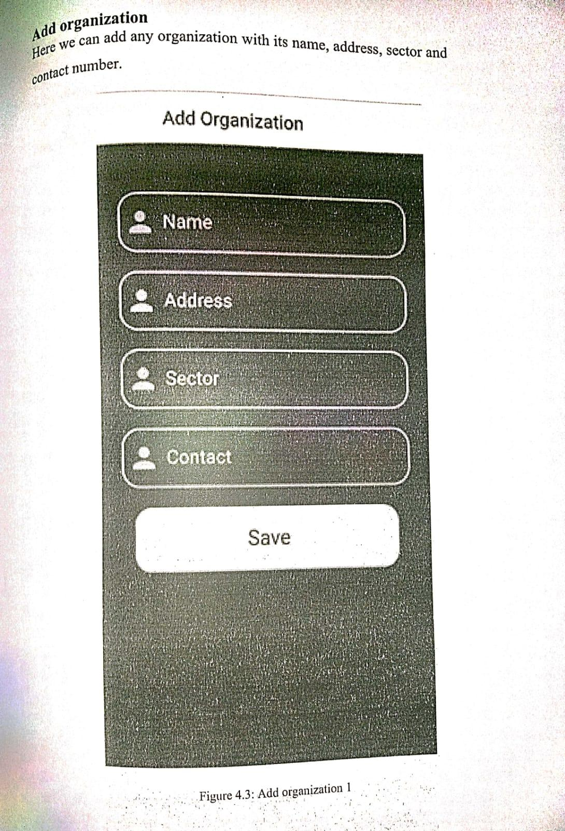

Figure 2.1 - Add Organization

In this Figure you can Register your Organization

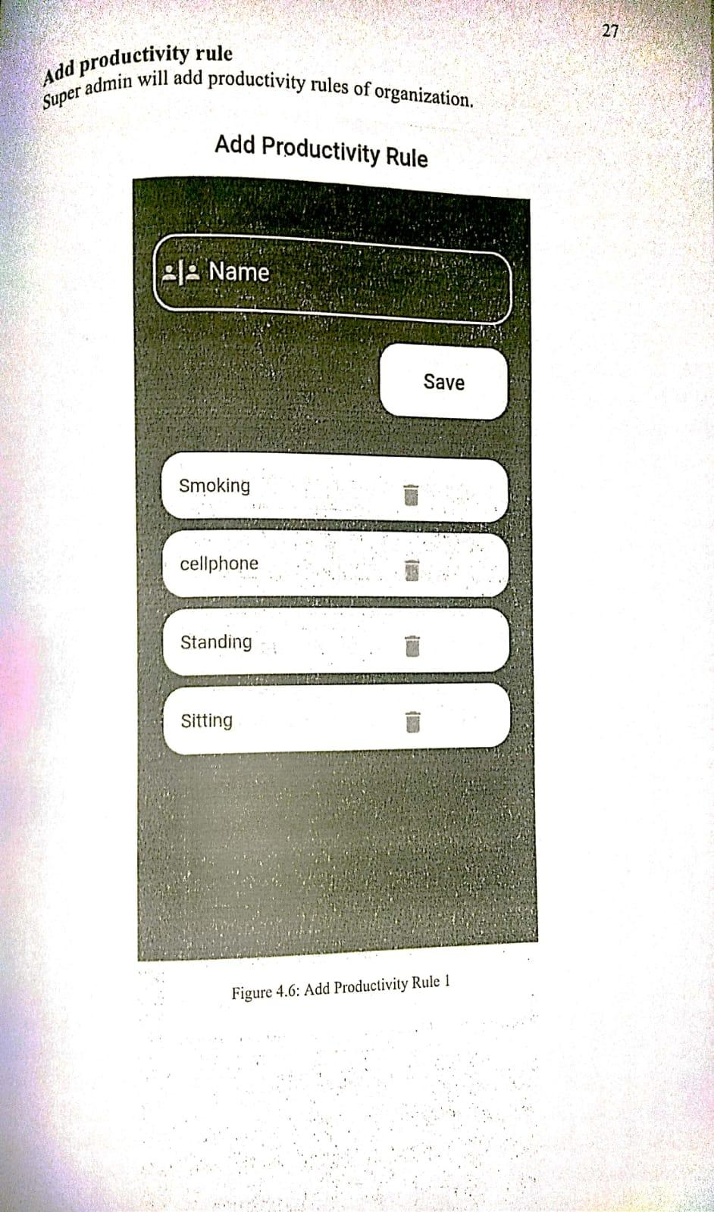

Figure 2.2 - Add Productivity Rule

In this figure 2.2 You can add the Productivity rules of the Organization which are concerned to be followed by employees in an organization.

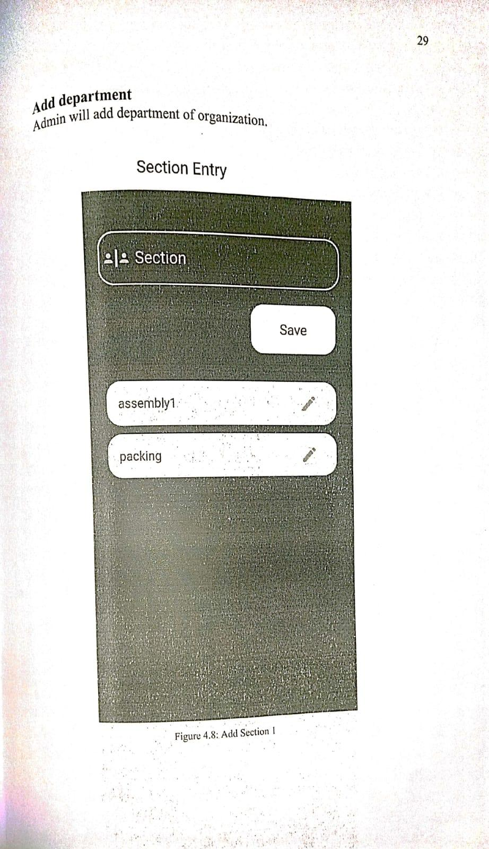

Figure 2.3 - Add Section

In this figure 2.3 you will add department of Organization

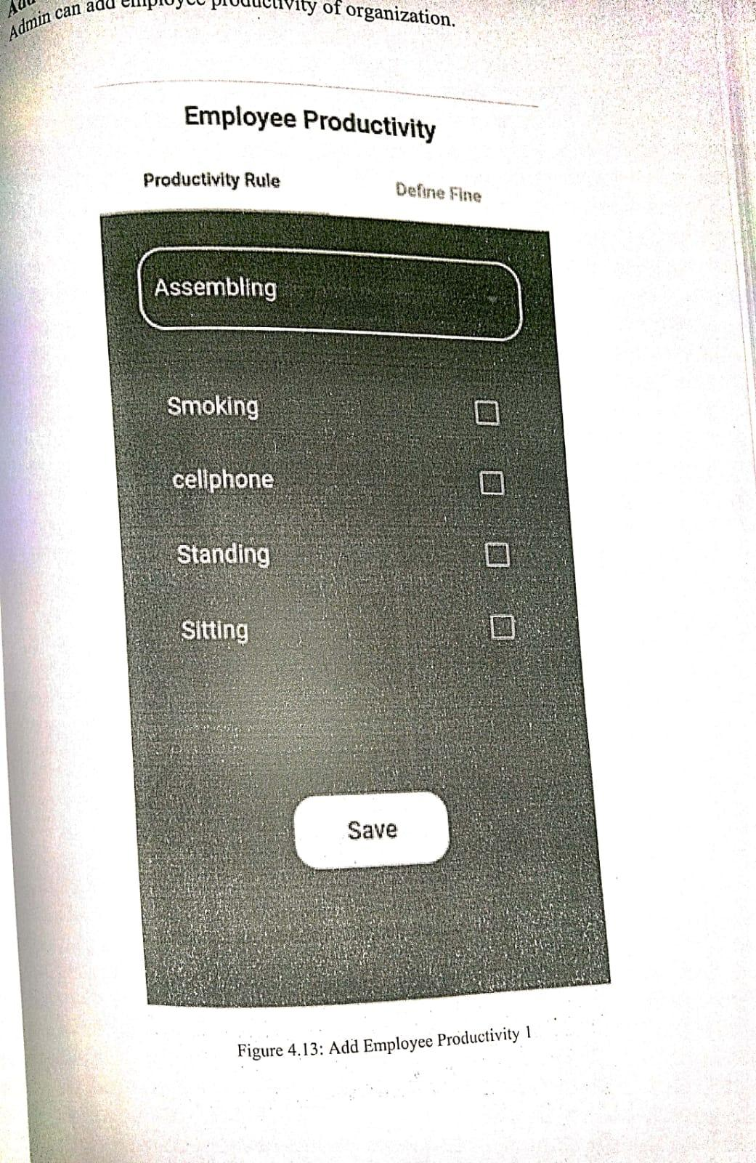

Figure 2.4 - Assign Productivity Rule

In this Figure 2.4 you can Assign Productivity Rules to employees

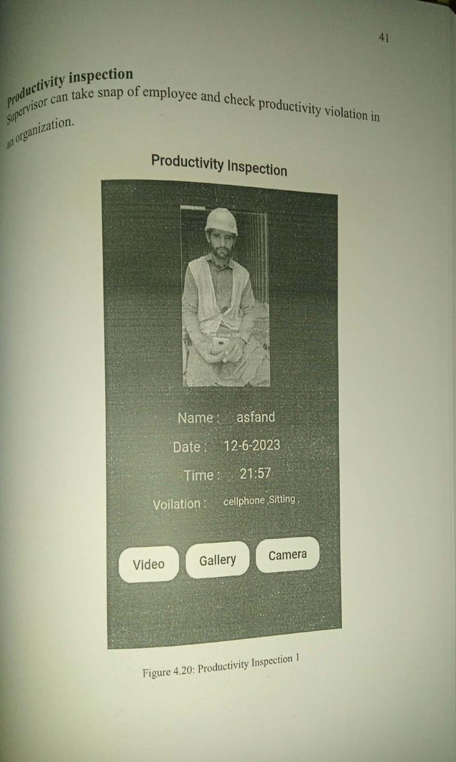

Figure 2.5 - Productivity Inspection

In figure 2.5 you can take snap of employee and check productivity violation in an organization

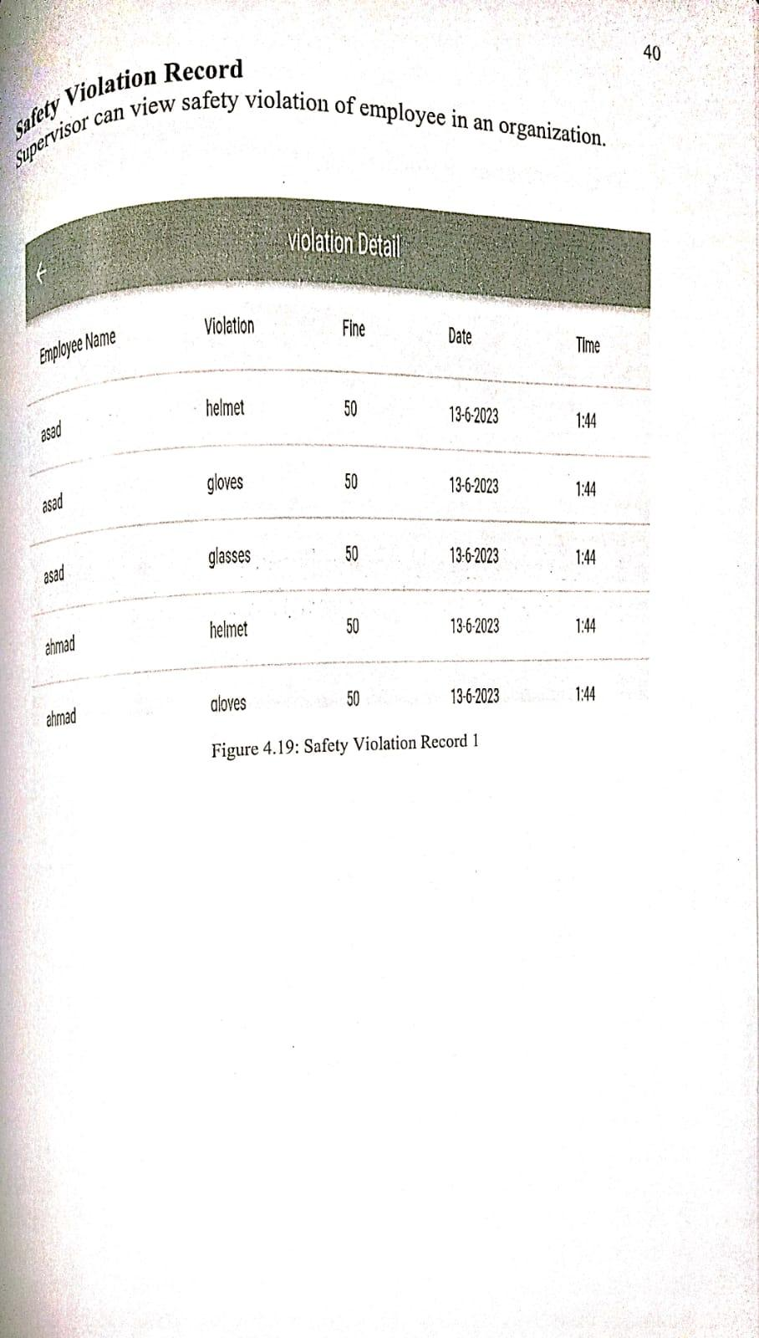

Figure 2.6 - Violation Detail

In Figure 2.6 you can view Violation done by an Employee

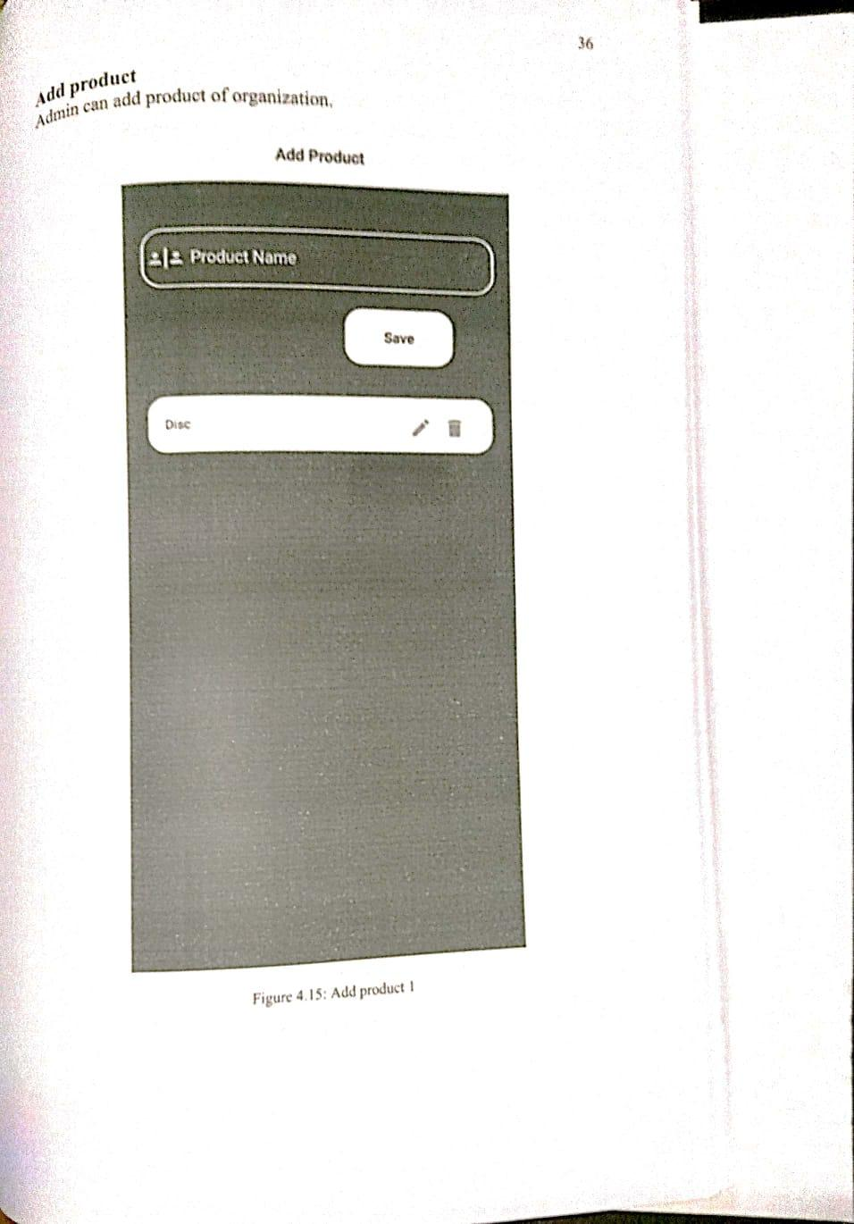

Figure 2.7 - Add Product

In Figure 2.7 you can add Product of Organization

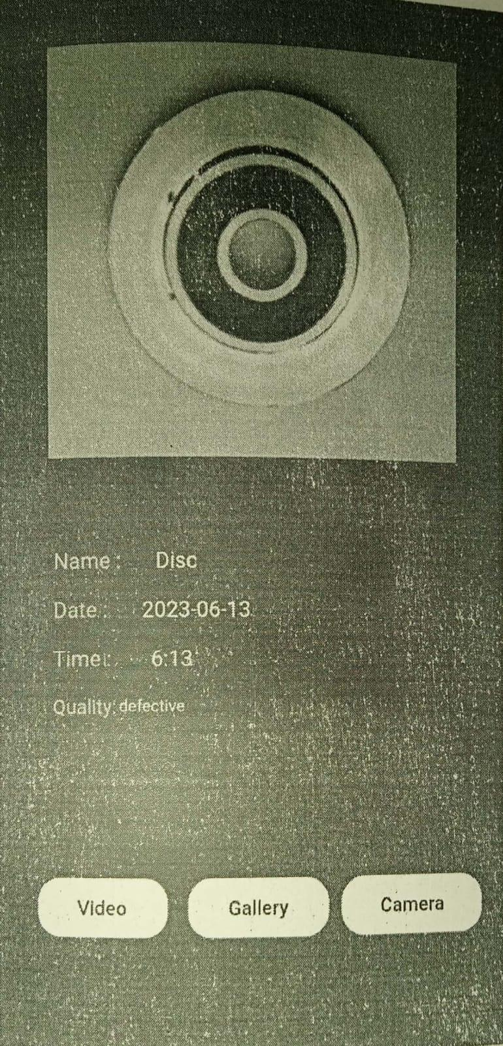

Figure 2.8 - Product Inspection

In figure 2.8 you can take snap of product and check whether the product is defected or not.

**Chapter 3**

# CONCEPTUAL DESIGN

All the concepts and flow of data that are used to develop this app are discussed in this chapter. Data store represents stored information (either temporary or permanently) that is used by software. Mostly applications are difficult to learn and used for the beginners and it is a problem for the new user.

## 3.1 Requirement Elicitation

The question is that from where the requirements are gathered? The requirements are gathered from the director of BIIT and from our supervisor. In each meeting there was discussion of assigning the objectives/requirements. We have followed each instruction from our supervisor and director.

## 3.2 Requirement Specification

A Requirement Specification is a collection of the set of all requirements that are to be imposed on the design and verification of the product. The specification- also contains other related information necessary for the design, verification and maintenance of our application.

### 3.2.1 Functional Requirements

According to the nature of attaining specific behavior of the Industry Watch application, the following specifications were made mandatory by the supervisor and the director:

**Login Page**

In this application, users must log in using their username and password to ensure secure access to the application’s features and data.

**Home Page**

Once logged in, user have control over various functions, including:

* **Violation Summary:** Allows users to view detailed summaries of employee rule violations. This includes reports and statistics on specific behaviors such as smoking, mobile usage, and sitting. Users can filter data by employee, time period, and type of violation.
* **Quality Monitoring:** Enables real-time monitoring of product quality, focusing on defect detection for a specified product. The system tracks defective items, calculates batch yields, and determines batch acceptance based on predefined rejection tolerance percentages.
* **Profile:** Users can access and manage their profile information, including login credentials, personal details, and preferences. This section also allows users to update their contact information and change their password.

**Employee Management**

The application provides employee management functionalities, including:

* **Add Employee:** Users can add new employees to the system by entering their personal details, job role, and assigned section. This function ensures that all employee information is accurately recorded in the system.
* **Edit Employee:** Users can update existing employee information, including changes to personal details, job role, and assigned section. This function helps maintain up-to-date records of all employees.
* **Delete Employee:** Users can remove employees from the system. This function ensures that the employee database remains current and only includes active employees.
* **Employee Details:** Users can view detailed information about each employee, including their personal details, job role, assigned section, and performance metrics. This section also includes a summary of any rule violations and the fines associated with those violations.
* **Violation and Fine Management:** Users can track and manage rule violations and fines for each employee. This includes viewing a history of violations, the fines applied, and any corrective actions taken.

### 3.2.2 Non Functional Requirements

These are requirements that our system can perform all the required functionalities without any ambiguity that make the system interactive and user friendly. It includes performance, availability, integrity, reliability and the performance of application.

### 3.2.3 Domain Requirements

It is requirement that comes from the application domain of the system that reflects the characteristics of that domain. The domain requirements of this system should concern about the requirements that reflect characteristics application like Android devices and Web and it requires a network connection to fetch data of users.

## 3.3 Logical Design

A Logical design describes the overall functionality of the system it means describing all the system in one picture. This is design for a dumb user so everyone can understand the system functionality. The process of logical design involves arranging data into a series of logical relationships called entities and attributes. An entity represents a chunk of information. In relational databases, an entity often maps to a table. An attribute is a component of an entity and helps define the uniqueness of the entity. In relational databases, an attribute maps to a column. A Logical design describes the overall functionality of the system it means describing all the system in one picture. All data are interconnected to each other in the form of tables.

### 3.3.1 Conceptual Diagram

A conceptual diagram is a drawing, rendering or map that visually describes at a high level, the particulars of the system in question. Conceptual diagram of this project is shown in **figure 3.1**.

This is the model used to show the big picture and clear meaning about the system working and functionality. Information is transmitted to the user and there is a web service that holds the data into the database. Database (SQL) server is responsible for web services and web services are responsible for application for the data synchronization. A conceptual diagram is a visual representation of how a system works. The overall working of the application is showed in simple pictorial form to help general people and clients to understand how the application works.

This application has two modules. The first is Defect Monitoring and the second is Employee Monitoring. In the Defect Monitoring module, an overhead camera will monitor the products on the conveyor belt and check if any product is defective. If a product is found to be defective, it will be removed from the conveyor belt. In the Employee Monitoring module, an overhead camera will continuously watch over employees to ensure they are fulfilling their job descriptions. If they are not, they will be fined according to the specific section and rules assigned.

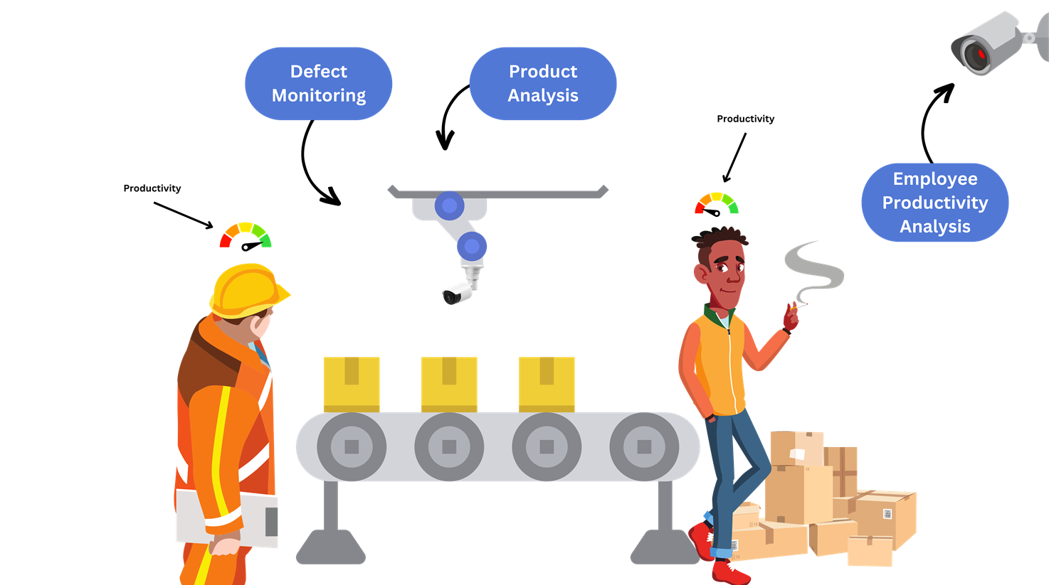

Figure: 3.1 Conceptual Diagram

|  |
| --- |
| **Approved By:** Dr Hassan Nazeer |

## 3.4 Database Design

Every application requires a database design because we have to store the data for every entity. All the data used in the project is saved in the database. Database Design is a collection of processes that facilitate the designing, development, implementation and maintenance of enterprise data management systems.

Following is the design of the database of our application.

### 3.4.1 Entity Relationship Diagram

An entity relationship diagram (ERD) shows the relationships of entity sets stored in a database. A basic ER model is composed of entity types (which classify the things of interest) and specifies relationships that can exist between entities (instances of those entity types).

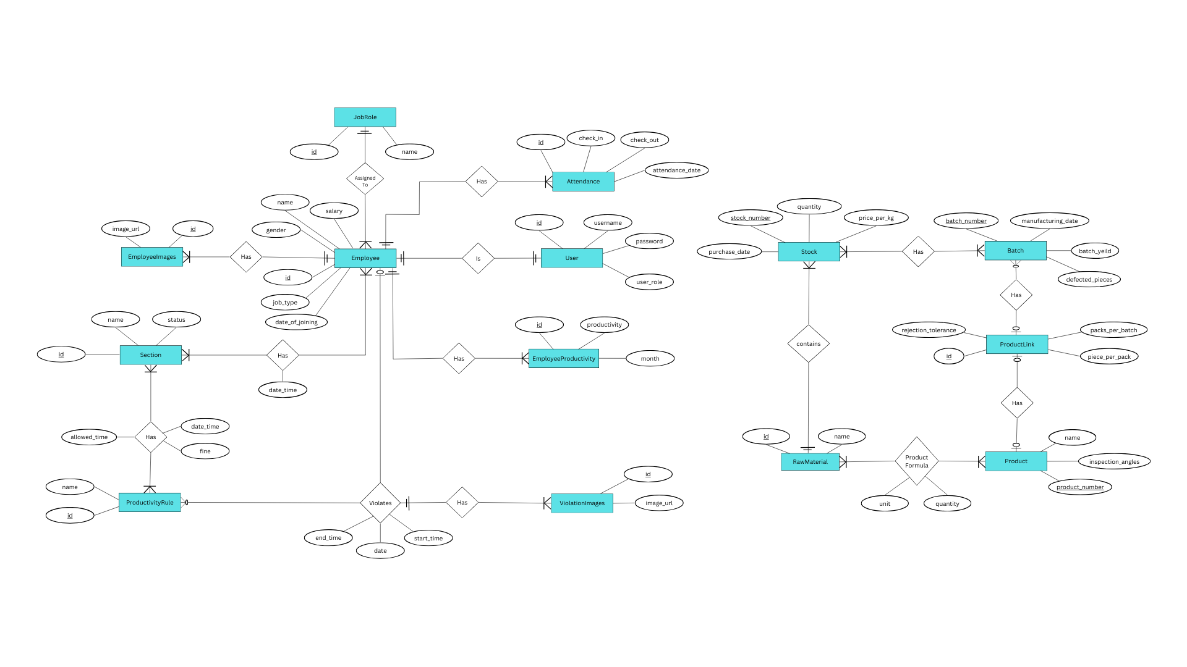Figure: 3.2 ERD

|  |
| --- |
| **Approved By:** Dr. Hassan Nazeer |

**Chapter 4**

# IMPLEMENTATION

This chapter includes the discussion about the tools and technologies which have been used for designing this application. It also includes how the application has been designed through coding. Also this chapter includes the discussion about the graphical user interface and this can be shown through project screenshots.

## 4.1 Tools and Technologies

Following are the tools that are used to develop this project.

* Pycharm Community Edition
* Visual Studio Code
* Android Studio
* XCode

## 4.2 Pseudo Code

**Admin Dashboard**

**Sections**

if (db.Sections Exist)

{

Show Sections in List

Click Button “Add Section” to add new Section

if (db.Rules Exist) Show Rules in list

else {

alert (“ Rules not found ”)

return to Sections List

}

Enter Section name

Select rules from List

Click Button “Confirm”

Click Button “Edit Section” to Edit Section

if (db.Rules Exist) Show Rules in list

else {

alert (“ Rules not found ”)

return to Sections List

}

update rules or Section Name

Click Button “Update” to Update Section

} else alert( “No Sections Found” )

**Supervisors**

if (db.Supervisors Exist)

{

Show Supervisors in List

Click Button “Edit” to Edit Supervisors

if (db.Sections Exist) Show Sections in dropdown

else display “ No Record or Sections Exist” in drop down

Update Supervisor's Name or Credentials

Select Section of Supervisor from DropDown

Click Button “Update” to Update Supervisor

} else alert( “No Supervisors Found” )

**Employee Productivity**

**Employee Record**

if (db.Employees Exist){

Show Employees in Card Grid

click on Employee Card to see Employee Details, Attendance and

Violation Summary along with Productivity

}

else alert( “Employees Not Found” )

**Add Employee**

Step 01: Enter Employee Data

Step 02: Click Button “Add” to add Employee

**Production**

**RawMaterials**

if (db.RawMaterials Exist)

{

Show Raw Materials in List

Click “Add Material” to Add new RawMaterial

Enter Name of RawMaterial

Click “ Add ”

} else alert( “No RawMaterials Found” )

**Add Product**

Step 01: Enter Product Name

Step 02: Select Inspection Angles

Step 03: Click on “Add Material” to make formula

if (db.RawMaterials Exist)

{

Show RawMaterials in DropDown

Select RawMaterial

Enter Quantity that is being used to make the Product

Click “ Add ” to Add the Raw Material to Product

} else {

alert( “no RawMaterial found” )

navigate back to Production Menu Page

}

Step 04: Click on “ Add Product ” to add new Product

**Inventory**

if (db.StockOfMaterial Exist)

{

Show Distinct Stock of Raw Material

Click on button “ Detail ” to check Details of specific raw material

such as Price and Purchase Date

if (db.StockDetailsOf(rawmaterialID) Exist) Show StockDetails in List

else alert (“ No Stock Found ”)

Click on button “ Add Stock ” to add new Stock of RawMaterial

if (db.RawMaterials Exist)

{

Show RawMaterials in DropDown

Select RawMaterial

Enter Quantity of the Stock in Kg

Enter Price per kg

Click “ Add ” to Add new Stock of RawMaterial

} else {

alert( “No RawMaterial found” )

navigate back to Stock List Page

}

} else alert (“ No Material Found ”)

**Products**

if (db.LinkedProducts Exist)

{

Show Products that are already linked to batch in a list

Click on Product number to see batches of the Product

Click on Batch Number to see whether the batch is accepted or rejected

Click on button “ Defected Images ” to Download Defective Images of Product

Click on button “ Link Product ” to Link a new Product to Batch

if (db.UnLinkProduct Exist)

{

Show Products in DropDown

Fill the Remaining Detail of Product batch

Click on button “ Save ” to link the product to batch

} else {

display “ No Unlinked Product Found ” on DropDown

}

Click on button “ Create batch ” to create new batch of Product

Fill the Text Fields

Chose stock of Raw Material

Click on button “ Add Batch ” to add new Batches of Product

} else alert (“ No Product Found ”)

**Supervisor Dashboard**

**Employee Monitoring**

Step 01: Choose Employee image or video from Gallery

Step 02: Click on button “ upload ” to check for Employee Productivity Analysis

if (isVioation(File) Exist)

{

display Violation Summary

Save Employee Fine

} else display Activity Summary

**Defect Monitoring**

Step 01: Choose Product image or video from Gallery

Step 02: Click on button “ upload ” to check for Product quality Analysis

if (isDefectiveProduct(File) Exist)

{

display Defect Summary

Save Defective pieces count

Calculate Yield of current Batch

} else display Products Summary

**My Attendance**

if (db.SupervisorAttendance Exist) Show Attendance in List

else alert (“ No Attendance Found ”)

**Employee Dashboard**

**Home**

if (EmployeeViolationSummary(employeeId) Exist) display Fine and Productivity

else alert ( “No record Found” )

**Attendance**

if (db.EmployeeAttendance Exist) Show Attendance in List

else alert (“ No Attendance Found ”)

**Violations**

if (EmployeeViolations(employeeId) Exist)

{

Show Employee Violation on List

Click on a specific violation to see Violation Detail and Images

if (db.ViolationDetail Exist) Show on the Labels and Images Views

else display (“ Violation Detail Not Found ”)

} else alert (“ No Violations found ”)

## 4.3 Graphical User Interface

Screenshots are all of the technologies are given below Flutter, React Native, iOS and Android respectively.

**Login Screen**

By entering the correct username and password, user will click the log in button to log in. Upon successful completion, the user is logged into the application as shown in Figure 4.1.

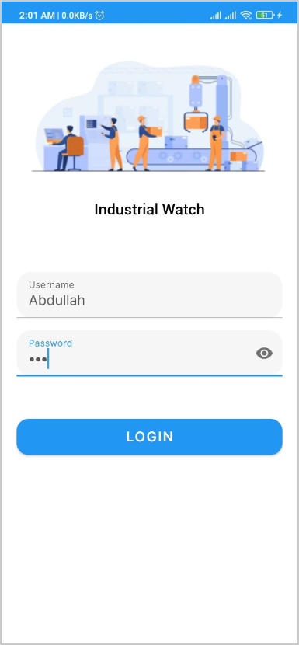

Figure: 4.1 Login Screen

**Admin Dashboard**

After Successful login as Admin user can see many options such as Sections, Supervisor, Employee Productivity and Production.

|  |  |
| --- | --- |
|  |  |
| **React Native** | **Android** |
|  |  |
| **IOS** | **Flutter** |

Figure: 4.2 Admin Dashboard

**Employee Record**

Admin can see multiple employees and their sections in a list and filter the employees as he desires according to name and section.

|  |  |
| --- | --- |
|  |  |
| **React Native** | **Android** |
|  |  |
| **IOS** | **Flutter** |

Figure: 4.3 Employee Record

**Employee Productivity Detail**

Admin can see the productivity of the employee and the total fine that is imposed on the employee by clicking on a specific employee card.

|  |  |
| --- | --- |
|  |  |
| **React Native** | **Android** |
|  |  |
| **IOS** | **Flutter** |

Figure: 4.4 Employee Productivity Detail

**Attendance**

Admin can see the attendance of a specific employee by clicking on the Attendance button.

|  |  |
| --- | --- |
|  |  |
| **React Native** | **Android** |
|  |  |
| **IOS** | **Flutter** |

Figure: 4.5 Attendance Screen

**Violations**

Admin can see the violation of an employee such as violated rule, time e.t.c along with a picture by clicking on the Violations button.

|  |  |
| --- | --- |
|  |  |
| **React Native** | **Android** |
|  |  |
| **IOS** | **Flutter** |

Figure: 4.6 Violations Screen

**Summary**

Admin can also see the summary of the employee such as total attendance, total violations, total fine of a specific month by clicking on Summary button.

|  |  |
| --- | --- |
|  |  |
| **React Native** | **Android** |
|  |  |
| **IOS** | **Flutter** |

Figure: 4.7 Employee Summary

**Production**

In the Production side, Admin can see multiple options like raw materials, add product, Inventory and products.

|  |  |
| --- | --- |
|  |  |
| **React Native** | **Android** |
|  |  |
| **IOS** | **Flutter** |

Figure: 4.8 Production Dashboard

**Add Product**

When the admin clicks on Add Product he will enter the product name, inspection angles and formula for the product from which it is being made.

|  |  |
| --- | --- |
|  |  |
| **React Native** | **Android** |
|  |  |
| **IOS** | **Flutter** |

Figure: 4.9 Add Product

**Add Material**

By clicking on add material Admin can define the raw material and its quantity to make the product.

|  |  |
| --- | --- |
|  |  |
| **React Native** | **Android** |
|  |  |
| **IOS** | **Flutter** |

Figure: 4.10 Add Material

**Products**

By clicking on products Admin can see the products that are already linked to the batch.

|  |  |
| --- | --- |
|  |  |
| **React Native** | **Android** |
|  |  |
| **IOS** | **Flutter** |

Figure: 4.11 Products Screen

**Link Product**

In order to link a product to the batch admin will click on the link product then define the batch details such as pack per batch and piece per pack and click on save button to save the information.

|  |  |
| --- | --- |
|  |  |
| **React Native** | **Android** |
|  |  |
| **IOS** | **Flutter** |

Figure: 4.12 Link Product Screen

**Batches**

Admin can see the batch of the products and by the color of the row admin will know that the batch is accepted, rejected or pending

|  |  |
| --- | --- |
|  |  |
| **React Native** | **Android** |
|  |  |
| **IOS** | **Flutter** |

Figure: 4.13 Batches Screen

**Batch Detail**

Admin can see further detail of the batch by clicking on a specific batch number or row to see the details like yield, defected pieces etc.

|  |  |
| --- | --- |
|  |  |
| **React Native** | **Android** |
|  |  |
| **IOS** | **Flutter** |

Figure: 4.14 Batch Details Screen

**Supervisor Dashboard**

After successful login as Supervisor, User can see this screen with multiple options such as Employee Monitoring, Defect Monitoring, Mark Attendance and My Attendance.

|  |  |
| --- | --- |
|  |  |
| **React Native** | **Android** |
|  |  |
| **IOS** | **Flutter** |

Figure: 4.15 Supervisor Dashboard

**Employee Monitoring**

In Employee Monitoring User will choose a video of the employee and upload it to check the violation.

|  |  |
| --- | --- |
|  |  |
| **React Native** | **Android** |
|  |  |
| **IOS** | **Flutter** |

Figure: 4.16 Employee Monitoring Screen

**Employee Monitoring Summary**

After successfully uploading video a Violation summary is generated with violated rule and accumulative time.

|  |  |
| --- | --- |
|  |  |
| **React Native** | **Android** |
|  |  |
| **IOS** | **Flutter** |

Figure: 4.17 Employee Monitoring Summary

**Defect Monitoring**

In Defect Monitoring, User will upload a video of the products to check whether the product is defective or not.

|  |  |
| --- | --- |
|  |  |
| **React Native** | **Android** |
|  |  |
| **IOS** | **Flutter** |

Figure: 4.18 Defect Monitoring Screen

**Defect Monitoring Summary**

After Successfully uploading Product video the summary of product is generated like defect types, names and count.

|  |  |
| --- | --- |
|  |  |
| **React Native** | **Android** |
|  |  |
| **IOS** | **Flutter** |

Figure: 4.19 Defect Monitoring Summary

**Mark Attendance**

User will upload the image or video of the employee to mark the attendance.

|  |  |
| --- | --- |
|  |  |
| **React Native** | **Android** |
|  |  |
| **Flutter** | **IOS** |

Figure: 4.20 Mark Attendance Screen

**Employee Home**

After Successful login as employee, User can see his productivity, total fine and total attendance

|  |  |
| --- | --- |
|  |  |
| **React Native** | **Android** |
|  |  |
| **iOS** | **Flutter** |

Figure: 4.21 Employee Home Screen

## 4.4 Algorithms

Algorithms play a crucial role in the implementation of the "Industry Watch" system, particularly in tasks such as object detection and facial recognition. Here are the key algorithms utilized in the project:

**Object Detection: YOLO (You Only Look Once)**

YOLO is a state-of-the-art object detection algorithm known for its speed and accuracy. YOLOv8 can be utilized to detect persons in camera frames captured in the workplace. YOLO divides the image into a grid and predicts bounding boxes and class probabilities for each grid cell, enabling real-time detection of persons in the video feed. (ultralytics - Delegates and Performance Variability, 2024)

**Facial Recognition: FaceNet**

FaceNet is a deep learning model for facial recognition developed by Google researchers. It maps facial features into a high-dimensional vector space, where distances between vectors can be used to measure similarity between faces. FaceNet can be utilized to compare facial embeddings and identify visitors based on their facial features captured by the system's cameras. (GeeksforGeeks - FaceNet, 2024)

**Chapter 5**

# CONCLUSION

In this chapter, we address the application's remark, as well as the application's future direction and limitations, which the user will need in the future.

## 5.1 Concluding Remarks

The Industry Watch application was developed and implemented effectively, meeting the specified requirements and objectives. It includes the primary modules necessary to provide users with an efficient and effective platform for monitoring employee productivity and product quality. The Employee Monitoring module ensures compliance with job descriptions and rules by continuously observing employees and assigning fines for violations. The Defect Monitoring module ensures product quality by detecting and removing defective products from the conveyor belt. This application provides a comprehensive solution for industrial settings, enhancing both employee performance and product quality assurance.

## 5.2 Future Direction

This project has significant potential for future growth. Due to its flexible architecture, the Industry Watch application can be easily upgraded to include additional features as needed. Future enhancements may include comprehensive activity records for users, a detailed summary on the homepage, and a live chat feature for real-time communication between users. These upgrades will further improve the application's utility and user experience.

## 5.3 Limitations

The Industry Watch app is user-friendly, requiring minimal technical knowledge but a stable internet connection. While offering robust monitoring features, it currently supports tracking only one person at a time, which may limit its use in multi-user environments. Customization might be needed to meet specific industrial needs or integrate with existing systems.

# REFERENCES

Brown, Michael, & Lee, S. (2021). Implementation of Overhead Camera Systems for Quality Assurance in Production Lines. *Proceedings of the 2021 International Conference on Manufacturing Automation*, (pp. 112-118).

*GeeksforGeeks - FaceNet*. (2024). Retrieved from GeeksforGeeks - FaceNet - Using Facial Recognition System: https://www.geeksforgeeks.org/facenet-using-facial-recognition-system/

Harris, Peter, & White, L. (2022). The Role of Machine Learning in Enhancing Industrial Monitoring Systems. *Journal of Artificial Intelligence in Manufacturing*, 567-584.

Johnson, Emily, & al, e. (2023). Employee Monitoring Systems: Enhancing Productivity and Compliance. *Journal of Industrial Engineering and Management*, 123-140.

Kim, Daniel, & al, e. (2023). Impact of Automated Employee Monitoring on Workplace Productivity. *International Journal of Human Resource Management*, 987-1002.

Smith, John, & Doe, J. (2022). Automated Quality Control in Manufacturing: A Case Study. *International Journal of Manufacturing Technology and Management*, 345-360.

Taylor, Robert, & al, e. (2022). Real-Time Monitoring and Analysis of Employee Performance Using Advanced Surveillance Technologies. *Journal of Organizational Behavior*, 201-218.

Thompson, Rebecca, & al, e. (2023). A Comprehensive Study on the Benefits of Real-Time Quality Monitoring in Manufacturing. *Journal of Quality Engineering*, 221-236.

*ultralytics - Delegates and Performance Variability*. (2024). Retrieved from ultralytics - Delegates and Performance Variability: https://docs.ultralytics.com/hub/app/android/ #delegates-and-performance-variability

Williams, Lisa, & Green, D. (2023). Innovative Approaches to Defect Detection in Manufacturing Processes. *International Journal of Advanced Manufacturing Systems*, 95-110.

Zhang, Ling, & Chen, W. (2022). Automated Defect Removal in Production Lines Using AI-Powered Vision Systems. *Journal of Robotics and Automation*, 450-468.

# ANNEXURE

#### Annexure A: Authentication

**Connection**

Step 1: Build API Connection.

**Login**

Step1: Enter Username and Password.  
Step2: Click on Login Button.  
Step 3: Click Signup if you haven't registered yet.

#### Annexure B: Menu

**Dashboard Screen**

On successful login, the user navigates to their dashboard.

**Sections**

Step 1: If Sections exist in the database, show sections in a list.  
Step 2: Click "Add Section" to add a new section.  
Step 3: If Rules exist in the database, show rules in a list.  
Step 4: Enter Section name and select rules from the list.  
Step 5: Click "Confirm".  
Step 6: To edit a section, click "Edit Section".  
Step 7: If Rules exist in the database, show rules in a list.  
Step 8: Update rules or section name.  
Step 9: Click "Update" to update the section.

**Supervisors**

Step 1: If Supervisors exist in the database, show them in a list.  
Step 2: Click "Edit" to edit supervisors.  
Step 3: If Sections exist in the database, show sections in a dropdown.  
Step 4: Update Supervisor's Name or Credentials.  
Step 5: Select section of supervisor from dropdown.  
Step 6: Click "Update" to update supervisor.

**Employee Productivity**

**Employee Record**

Step 1: If Employees exist in the database, show employees in a card grid.  
Step 2: Click on an Employee Card to see employee details, attendance, violation summary, and productivity.

**Add Employee**

Step 1: Enter Employee Data.  
Step 2: Click "Add" to add the employee.

**Employee Ranking**

Step 1: If Employees exist in the database, show employees according to their productivity ranking.

**Production**

**Raw Materials**

Step 1: If Raw Materials exist in the database, show them in a list.  
Step 2: Click "Add Material" to add a new raw material.  
Step 3: Enter the name of the raw material.  
Step 4: Click "Add".

**Add Product**

Step 1: Enter Product Name.  
Step 2: Select Inspection Angles.  
Step 3: Click "Add Material" to make the formula.  
Step 4: If Raw Materials exist in the database, show raw materials in a dropdown.  
Step 5: Select raw material and enter the quantity used to make the product.  
Step 6: Click "Add" to add the raw material to the product.  
Step 7: Click "Add Product" to add a new product.

**Inventory**

Step 1: If Stock of Material exists in the database, show the distinct stock of raw material.  
Step 2: Click "Detail" to check details of specific raw material such as price and purchase date.  
Step 3: If Stock Details of the raw material ID exist in the database, show stock details in a list.  
Step 4: Click "Add Stock" to add new stock of raw material.  
Step 5: If Raw Materials exist in the database, show raw materials in a dropdown.  
Step 6: Select raw material, enter the quantity of the stock in kg, and enter the price per kg.  
Step 7: Click "Add" to add new stock of raw material.

**Products**

Step 1: If Linked Products exist in the database, show products that are already linked to the batch in a list.  
Step 2: Click on Product number to see batches of the product.  
Step 3: Click on Batch Number to see whether the batch is accepted or rejected.  
Step 4: Click "Defected Images" to download defective images of the product.  
Step 5: Click "Link Product" to link a new product to a batch.  
Step 6: If Unlinked Product exists in the database, show products in a dropdown.  
Step 7: Fill the remaining details of the product batch.  
Step 8: Click "Save" to link the product to the batch.  
Step 9: Click "Create batch" to create a new batch of the product.  
Step 10: Fill the text fields, choose stock of raw material, and click "Add Batch" to add new batches of the product.

#### Annexure C: Supervisor Dashboard

**Employee Monitoring**

Step 1: Choose an employee image or video from the gallery.  
Step 2: Click "Upload" to check for employee productivity analysis.  
Step 3: If a violation file exists, display the violation summary and save the employee fine.  
Step 4: If no violation is found, display the activity summary.

**Defect Monitoring**

Step 1: Choose a product image or video from the gallery.  
Step 2: Click "Upload" to check for product quality analysis.  
Step 3: If a defective product file exists, display the defect summary, save the defective pieces count, and calculate the yield of the current batch.  
Step 4: If no defect is found, display the product summary.

**My Attendance**

Step 1: If Supervisor Attendance exists in the database, show attendance in a list.

#### Annexure D: Employee Dashboard

**Home**

Step 1: If Employee Violation Summary exists for the employee, display employee fine and productivity.

**Attendance**

Step 1: If Employee Attendance exists in the database, show attendance in a list.

**Violations**

Step 1: If Employee Violations exist for the employee, show employee violations in a list.  
Step 2: Click on a specific violation to see violation details and images.  
Step 3: If Violation Detail exists in the database, show the details on the labels and image views.

**Edit Profile**

Step 1: Enter new credentials and name.  
Step 2: Click "Update" to save the information.

**Summary**

Step 1: If Employee Summary for the month and employee ID exists, show employee summary on the UI.